East Bay Republican Club
(formerly East Bay Republican Women)

Cordially invites you and your friends to our next Spring Luncheon

Friday, April 28, 2023
11:30 AM - 1:30 PM

Sequoyah Country Club
4550 Heafey Rd. Oakland, CA

With special guest speaker
Williamson Evers, Ph.D.

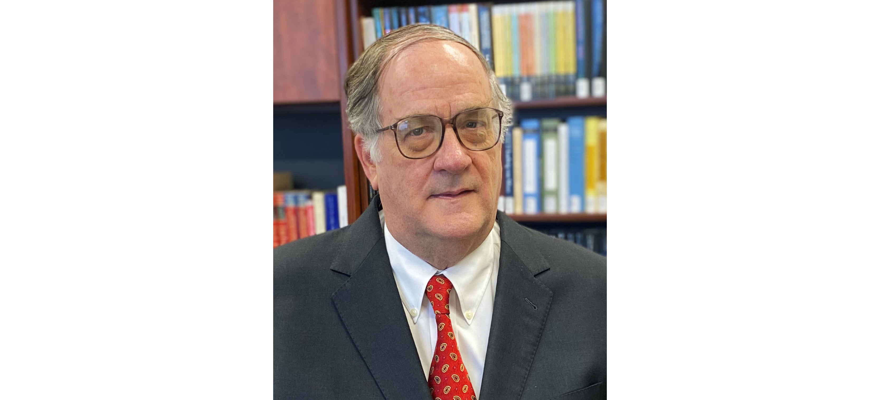
Topic: “California’s Public School Shambles - And What We can Do About It”

Williamson M. “Bill” Evers is a Senior Fellow and Director of the Center on Educational Excellence at the Independent Institute in Oakland. Dr. Evers was the US Assistant Secretary of Education for Planning, Evaluation and Policy Development from 2007-2009 as well as being a longtime fellow at the Hoover Institute. In addition, Dr Evers joined the 2016 Trump-Pence transition team focusing on the US Department of Education. He received his B.A., M.A. and Ph.D. degrees in political science from Stanford.

Please join us as Dr. Evers enlightens us on where the California public schools are going and how we can get involved!

$50 for Members and Guests

Please RSVP to Wendy Gerhardy before April 21. To RSVP, please mail your check, payable to EBRC to: Wendy Gerhardy, 340 La Salle Avenue, Piedmont 94610. You can also pay directly (via PayPal or credit card) from the Events tab at our website: www.eastbayrepublicanclub.org. Please include name(s) of guest(s.) If you are on our mailing list, you will receive an E-vite.
Questions about membership: email: eastbayrclub@gmail.com

