**The Elephant’s Trumpet**



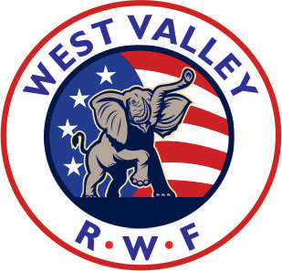

The Award-Winning Newsletter of a Diamond Award Club!

**A Publication of the West Valley Republican Women Federated**

**Founded in 1952**

Affiliated with National Federation of Republican Women,

California Federation of Republican Women

**VOLUME 71, Issue 2 www.westvalleyrwf.org February 2023**

**2023 BOARD OF DIRECTORS**

President

Shannon Wagner

408-655-8010

1st VP/Programs

Robin McCarthy

408-612-8476

2nd VP/Membership

JoAnn Destro

408-605-9608

3rd VP/Ways & Means Kay Young

408-446-4144

*Recording Secretary* Kathie Topham

408-257-6261

Treasurer

Mary Goodman

408-806-4671

Corresponding Secretary

Lorene Milligan

*Director-at-Large*

Mayme Abbott

408-241-4513

*Newsletter*

Editor:Bunny Hacker

Distribution:Kris Saba

*Reservations Hostess*

Grace Russo

408-499-1695

**CFRW Region 3 Director**

Bunny Hacker

[Bunny328@reagan.com](mailto:Bunny328@reagan.com)

**STANDING COMMITTEES**

*Achievement Awards*

Bunny Hacker

*Americanism*

Cindy Jerdonek

*Campaign/Central Committee*

Kay Young

*Caring for America/Armed Services*

Debbie Dempsey

*Chaplain*

Marcia Lines

*Historian*

Christine Austin-Walker

*Hospitality*

Grace Russo

*Newsletter*

Bunny Hacker, Editor

Kris Saba, Distribution

*Phone Tree*

Diana Mandarino

*Publicity/Social Media*

Bunny Hacker

*Voter Registration*

OPEN

**Special Committees:**

Membership Growth:

Volunteer to serve with our 2nd VP JoAnn Destro to help with her efforts to recruit new members with outreach, mailings, etc.

**Legislation:**

**Mayme Abbott** follows and reports at our meetings on the legislative items that are posted on our CFRW site, <https://cfrw.org>, and many of which are printed in our newsletters.

**NEXT MEETING**

**FEBRUARY 16, 2023**

***Featuring***

***DAMIAN SCHIFF***

***Pacific Legal Foundation***

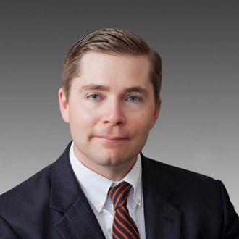

**\*\*\* Three Flames \*\*\***

**1547 Meridian Ave.**

**San Jose CA 95125**

**11:30am - Check In**

**12:00am - Call to Order**

**\*\*\* Cost of Program: $32 \*\*\***

*Includes program, a delicious lunch, and a soft drink, coffee or tea! and (taxes & gratuities also included)*

**MENU OPTIONS:**

**CHICKEN CAESAR SALAD**

Grilled chicken breast on top of crisp Romaine, tossed with Caesar dressing w/croutons & Parmesan cheese

**CALIFORNIA TURKEY SANDWICH**

*Oven-roasted turkey, avocado, lettuce, tomato & red onion*

*on sliced sourdough; served w/Fries*

**CALAMARI DORE**

Dipped in a light egg wash & pan fried until golden. Served with fresh lemon & tartar sauce.

**It is imperative you RSVP by February 9th**

**Lunches must be pre-ordered 1 week in advance**

**Call Grace, 408-499-1695**

**A check can be mailed to: Grace Russo,**

**2393 Karen Dr. #3 - Santa Clara, CA 95050**

**Make Check payable to West Valley RWF.**

**A reservation made is a reservation paid!**

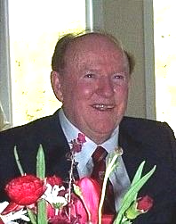

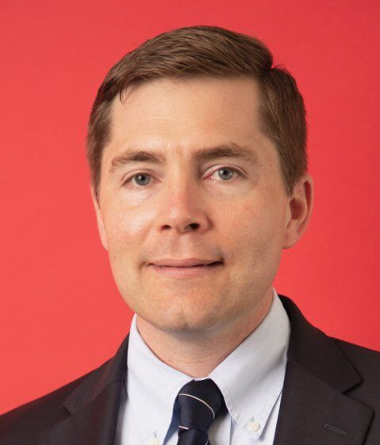

***SHANNON WAGNER***

***West Valley RWF President***

**PRESIDENT’S MESSAGE**

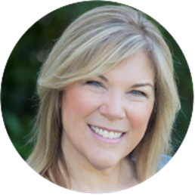

We have so much to look forward to this year. Be sure and mark your calendars for our monthly meetings on the third Thursday of each month as we have a fantastic line up of speakers in the coming months. Our 1st Vice President-Programs, Robin McCarthy, has been hard at work getting this planned and organized! This month, we’ll hear from Damien Schiff of Pacific Legal Foundation speaking about recent Supreme Court Cases. I can’t say enough about Pacific Legal Foundation. They do yeoman’s work in fighting to protect property rights and civil liberties from government overreach. In March, we’ll hear from Monte Sereno Councilwoman, Liz Lawler, who ran for state assembly in November. In April, Fran Aquila, the author of “Sara Palin Out of Nowhere” will join us. The list continues and you don’t miss out so mark your calendars now!

How are we all doing on New Year’s Resolutions? As we continue to strive to achieve our individual goals, let’s add to that our collective goal to grow our club membership. There are so many current local issues that resonate with people regardless of party affiliation, that opportunities to open a dialog are many. Whether it be increasing crime in our neighborhoods, cancel culture, city planning and housing issues or concerns affecting students in our schools, there are plenty of opportunities to connect with people who share our concerns and values. As your discussions evolve, invite them to a meeting, all are welcome. I look forward to seeing you there!

*-Shannon*



**MEET OUR SPEAKER**

Damien Schiff is a senior attorney at Pacific Legal Foundation. He leads its environmental practice group, a unique initiative that draws broadly from PLF’s expertise and success in [property rights](https://pacificlegal.org/property-rights/) and [separation of powers](https://pacificlegal.org/separation-of-powers/)  litigation. Over the years,

Damien has represented hundreds of landowners and property rights advocates to defend their liberties against heavy-handed and unwarranted environmental and land-use regulation. His litigation experience includes [*Sackett v. U.S. Environmental Protection Agency*](https://pacificlegal.org/case/sackett-v-environmental-protection-agency/),  [a groundbreaking decision](https://www.cato.org/sites/cato.org/files/serials/files/supreme-court-review/2012/9/scr-2012-schiff.pdf)  in which the U.S. Supreme Court upheld the right of landowners to challenge Clean Water Act compliance orders issued by EPA, and *Contoski v. Norton*, PLF’s successful effort to force the federal government to make good on its promise [to delist the bald eagle](https://www.mprnews.org/story/2007/02/06/eagledevelopment) from the Endangered Species Act.

Immediately prior to joining PLF, Damien clerked for Judge (and former PLF attorney) Victor Wolski of the United States Court of Federal Claims. Damien credits the mentoring and examples of Professor Siegan and Judge Wolski for his decision to pursue a career in liberty-based public interest litigation.

Damien lives in Sacramento with his wife, two young sons, four chickens, and a cat named Princess. In his off hours he enjoys stamp collecting, Gregorian chant, and martinis—preferably at the same time.

**“Government’s first duty is to protect the people,**

**not to run their lives.” - Ronald Reagan**



In Memoriam

It is with great sadness we report tthe passing of our Associate Member John Eshleman, the husband to our legacy member Kay Eshleman and father to our long-time member and former newsletter editor Anne Rasor. West Valley Republican Women

wish to convey our deepest sympathies to Kay and her family. Visit this link to read some of John’s accomplishments: <https://tinyurl.com/bdhtjvww>.

**Get The Pigs Out Of The Creek"**

**By John Kennedy**

**A light-hearted and fun read, submitted by Kay Young**

*This John Kennedy graduated magna cum laude in political science, philosophy, and economics from Vanderbilt University, was president of his senior class, and was elected to Phi Beta Kappa. He received his law degree from the University of Virginia School of Law, where he was an executive editor of the “Virginia Law Review” and elected to the Order of the Coif. He earned a Bachelor of Civil Law degree with first class honors from Oxford University (Magdalen College) in England, where he studied under Sir Rupert Cross and Sir John H. C. Morris.*

First of all, I’m John Kennedy, not that John Kennedy; I am the other John Kennedy, (R) Senator representing the great state of Louisiana. Permit me to tell you what I believe.

* I believe America was founded by geniuses but is now run by idiots
* I believe you can’t fix stupid, but you can vote them out of office.
* When was the last time you heard of anyone trying to sneak into China?
* America is so great that people who hate it refuse to leave.
* Let me say something about the Biden administration - the Biden administration sucks.
* I believe exercise makes you look better naked, but so does alcohol.
* Welfare should be a bridge, not a parking lot.
* Weakness invites the wolves.
* We must arm for peace.
* We don’t have a gun control problem, we have an idiot control problem.
* Free advice friends: if Government tells you not to buy a gun, buy two.
* I believe if you hate police officers, the next time you are in trouble, call a crack-head.
* Here’s a free tip - cops will leave you alone if you don’t do stupid things.
* I believe we need an election day, not an election month.
* I believe you should be able to prove who you say you are when you vote.
* I believe 400,000 bodies buried at Arlington National Cemetery are the reason you should stand for the National anthem.
* I believe the water won’t clear ‘til you get the pigs out of the creek.
* I believe love is the answer, but you should own a gun, just in case.

**😄 😄 😄**

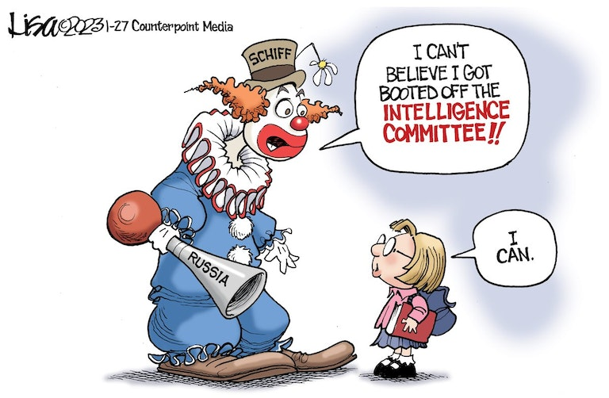 







**California Federation of Republican Women**Mary Ervin, President

**Submitted by the CFRW Legislative Analyst Committee  *Theresa Speake, Karen Contreras,   
and Lou Ann Flaherty***

**[GOVERNOR NEWSON DRAFT 2023-2024 BUDGET](https://ebudget.ca.gov/budget/2023-24/" \l "/Home" \o "This external link will open in a new window" \t "_blank)**

The Governor is required by law to have a draft budget each year by mid-January with the final budget required to be approved by the State Legislature by mid-June. The draft budget allows the State of California to operate and deal with legislation on spending bills. Even after approval of the final budget, the Legislature can pass spending bills known as trailer bills which do not have to be reviewed through the committee bill process.

**NEW 2023-2024 BUDGET**

**$297 BILLION** (State’s reserve “rainy day fund” of $35 Billion is untouched.)

This represents **a DEFICIT of $22.5 BILLION**. The deficit is being blamed on reduced tax revenue because of the stock market declines, multiple federal reserve bank interest rate increases, continued high inflation and reliance on capital gains.

It should also be noted that in the **2022-23 budget** there was a ***budget surplus of $97.5 billion****.* This year’s draft budget has a **deficit of $22.5 billion.** (This actually represents a deficit swing of **$102 billion** (last year’s surplus plus this year’s deficit.)

Budget items untouched include but are not limited to education and homelessness funding and sustains $44 Billion for statewide infrastructure projects including funding to accelerate the transition to zero-emission vehicles.

It also includes an allocation of $8.5 billion to CAPERS (State Retirement fund) and another $1.2 billion toward the State unfunded liability.

An attempt to balance the budget requires accounting maneuvers that are unclear, hard to identify, and confusing.

They include:

1. $7.4 billion in funding delays
2. $5 billion in reductions and pullbacks (where and when unknown)
3. $4.3 billion in fund shifts
4. $3.9 billion in trigger reductions

a. items placed in a “trigger” would restore the reductions at the 2024 Governor’s Budget should sufficient funds be made available to cover certain commitments

1. $1.2 billion in limited revenue generation and building

Now if this sounds unclear to you, you are not alone because these maneuvers are hard to specifically identify.

The budget and spending will be watched closely by your Legislative Analyst.

**To contact your U.S. Representatives, call the Capitol Switchboard at (202) 224-3121**

**Legislative Portal links- Express your support or opposition to a bill or directly to the Legislative committee currently reviewing it (as an individual, not as a member of RWF or CFRW) -** [**click here**](https://calegislation.lc.ca.gov/Advocates/faces/index.xhtml?mc_cid=6d9cd35c91&mc_eid=ca3b8dc7f0)**, or the bill’s author-**[**click here**](https://leginfo.legislature.ca.gov/faces/home.xhtml?mc_cid=6d9cd35c91&mc_eid=ca3b8dc7f0), **enter your bill # and look for tab at top of the bill page labeled “Comments to Author”**



**NATIONAL FEDERATION OF REPUBLICAN WOMEN**

**There’s a Place for You at Our Table!**

***Join or Renew Today!***

****

Founded in 1938, the National Federation of Republican Women is one of the largest women’s political organizations in the country with thousands of active members across the nation. In California (CFRW) the West Valley RWF club is your local affiliate!

We empower women from all backgrounds in the political process and provide a forum for women to serve as leaders in the political, government and civic arenas. We work to promote the principles, objectives and policies of the Republican Party; elect Republican candidates; inform the public through the political education and activity of our members; and, increase the effectiveness of women in the cause of good government.

Through our diversity of age, culture, opinion and experience, women are the strength of 21st century American politics. Believing that this rich tapestry is what makes us strong, the NFRW unites women as a collective force to positively impact the direction of our nation while also advancing the power of women through political access and participation.

The NFRW offers information, programs and privileges to members while drawing on their collective talents, ideas and desire to participate. From career professionals, students and teachers to elected officials, small business owners and mothers, we attract women from all walks of life.

We welcome all registered Republican women and hope you will join our national network and help us make a difference in the communities of our great nation.

**LOCAL MEMBERSHIP**

The Federation includes our California Republican Women Federated with local clubs in communities across the state. Joining **West Valley RWF** is a great way to participate in the political process at the grassroots level, develop leadership skills and network with women in your community. West Valley RWF membership dues include your membership in our California Federation and in the National Federation of Republican Women.

***JOIN OR RENEW NOW FOR 2023!***

Please fill in the following information and enclose with your check made **payable to West Valley RWF**.

Mail to: **JoAnn Destro – 1521 San Andreas Ave. – San Jose CA 95118**

--------------------------------------------------------------------------------------------------------------------------------

**Print Name:** \_\_\_\_\_\_\_\_\_\_\_\_\_\_\_\_\_\_\_\_\_\_\_\_\_\_\_\_\_\_\_\_\_\_\_\_\_\_ E-mail: \_\_\_\_\_\_\_\_\_\_\_\_\_\_\_\_\_\_\_\_\_\_\_\_\_\_\_\_\_\_\_\_\_\_

[\_] I am registered as Republican

Address:\_\_\_\_\_\_\_\_\_\_\_\_\_\_\_\_\_\_\_\_\_\_\_\_\_\_\_\_\_\_ City\_\_\_\_\_\_\_\_\_\_\_\_\_\_\_\_Zip:\_\_\_\_\_\_\_\_\_\_\_Phone:­­­­­­­­­­­­­­­\_\_\_\_\_\_\_\_\_\_\_\_\_\_

[\_] *Renewal*  [\_] *New Member*  [\_] *Sustaining*  [\_] *Associate****\**** [\_] *College*  [\_] +*Donation*

$45 $45 $60or + $20 $27 as desired

**[We do not use your e-mail for anything other than important Federation communications!]**

(**\*Associate women**: please note the name of the Federated club to which you are paying your regular membership dues: \_\_\_\_\_\_\_\_\_\_\_\_\_\_\_\_\_\_\_\_\_\_\_\_\_\_\_\_\_\_\_\_\_\_\_\_\_\_\_\_).

**\* Associate men: Republican Gentlemen are always welcome to attend our General Meetings, and we invite you to join us in a supporting role as Associate Members!**

**WEST VALLEY RWF**

c/o Bunny Hacker

55 Church St., #1301

Los Gatos, CA 95030-6922

**RETURN SERVICE REQUESTED**

**UPCOMING EVENTS**

**MARK YOUR CALENDAR!**

February 8 BOD meeting at home of Kathie Topham, 10:00 a.m.

February 14 **Valentine’s Day**

February 16 West Valley RWF lunch meeting w/**Damian Schiff, Pacific Legal Foundation** 11:30-1:30 at Three Flames

February 20 **Presidents’ Day**

March 8 BOD meeting at home of Kathie Topham, 10:00 a.m.

March 12 Daylight Savings Time begins

March 16 West Valley RWF lunch meeting w/**Liz Lawler,** Former candidate for CA-28. 11:30-1:30 at Three Flames

March 17 **St. Patrick’s Day**

April 9 **EASTER SUNDAY**

April 12 BOD meeting at home of Kathie Topham, 10:00 a.m.

April 20 West Valley RWF lunch meeting w/**Fran Aquila,** Author “Sarah Palin Out of Nowhere

May 20 West Valley RWF lunch meeting w/**TBA**

June 15 West Valley RWF lunch meeting w/**Daniel Reed, NRA**

“Like” us on Facebook: [**https://www.facebook.com/westvalleyrwf**](https://www.facebook.com/westvalleyrwf)

Click here to send us an email: [**westvalleyrwf@gmail.com**](mailto:westvalleyrwf@gmail.com)

S



***CFRW is officially chartered by the California Republican Party (CRP)!***

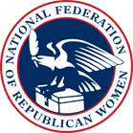

***NFRW is officially chartered by the RNC and CA is the largest Federated state in the Nation!***

