Marin Republican Women Federated
Luncheon/Speaker Meeting, Wed. Oct. 26th
Location: The Club at McInnis, San Rafael, CA.

11:30 am – 1:00 pm

Speaker: Mark Hill, Strategic Advisor at Sotec, Former Marin GOP County Chair

Topic: Hard Facts Matter--A Businessman Looks At Politics & The Economy In the Era of “ESG"

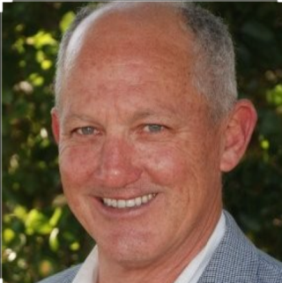
Mark Hill is a veteran of the United States military and a UC Berkeley graduate. After serving his country honorably and graduating from Berkeley, he went on to intern with then Senator Pete Wilson. Mark has worked at a senior level in private business for nearly forty years. His impressive resume includes a four-year stint as Chair of the Marin Republican Central Committee. Mark now lives in Napa where he is a senior advisor at an environmental services company.
While we are focusing on the election, we should never forget that political change is often driven by the business environment. Inflation and the looming crisis of our underfunded public pensions threaten our financial survival. We also now face the threat of “Environment & Social Governance” scores. While a mere twenty years ago businesses were judged on their profitability, today major companies are judged by how “woke” they can be. If your pensions are invested in the stock market, Environment & Social Governance could threaten your financial future. Please join Mark Hill and us to learn about the high costs of ESG.

Sarah Nagle, 1st VP, Programs

Reservations: $ 36 members/ $38 non-members Deadline: Friday, October 21st

I will attend Oct. 26th Email: Phone: ______________

Name: _________________________________Entree Choice: ___________________

Lunch Choice:

___ Grilled Salmon Salad
OR
___ Pot Roast with mashed potatoes and vegetables

Please mail in your payment so that check-in at the event is expedited.

Make check payable: MRWF
Mail reservations to: Bonnie Stevens, 100 Thorndale Drive # 140, San Rafael, CA 94903

Reservations: Email: events@marinrepublicanwomen.com

Notice: Advance reservations required. Lunch reservations, unless cancelled the Friday before the event, will be billed to you.

