TRI-VALLEY REPUBLICANS

2025: We’re Blessed with the Opportunity to Stand for Something - For Liberty and Freedom and Fairness.
And These are Things Worth Fighting for, Worth Devoting Our Lives To… President Ronald Reagan

Thursday, July 10, 2025
Come One… Come All… All Are Welcome!
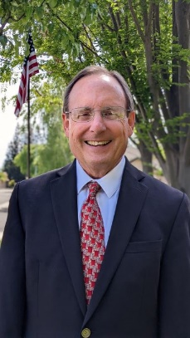
We Welcome Special Guest Speaker: Milton Matchak
“Pacific Justice Institute - What Legally and Culturally is Happening in our State and Nation – What We Do, Who We Help”
I am a 1977 graduate of San Jose State University with a Bachelor’s Degree in Political Science. I earned my Juris Doctor Degree from Oak Brook College of Law and Government Policy in October of 2000. I am a California licensed attorney. I am retired from over eighteen and ½ years as a criminal prosecutor for a small California County District Attorney’s Office. I would like to continue to use my position as an attorney to advance God’s Kingdom and His work.

The majority of my legal career was in criminal prosecution except for a very brief stint prior with a solo practitioner. I have the experience of hundreds of hours in the courtroom advocating before judges and triers of fact. I have conducted over twenty trials, and dozens of contested hearings such as motions to suppress and preliminary hearings. But I have always had an interest and desire to practice in constitutional law. I am grateful for the opportunity to practice civil law with Pacific Justice Institute especially in the area of constitutional law, religious liberty, parental rights, etc. I have been with Pacific Justice Institute since late April of 2022. I was grateful to be a part of the BART trials in the summer and fall of 2024.

Most importantly, I am a Christian, saved by the grace and mercy of Jesus Christ. I have a love of God’s word. It is my growing passion to share the good news of the Gospel of Jesus Christ with the world around me. I have over 70 years of life experience. I am a husband (50 years in June of 2025), father (9 children), grandfather (23 and hoping for more).

PLEASE JOIN US FOR A FABULOUS BUFFET DINNER AND SPEAKER THIS IS A NOT-TO-MISS EVENT

Location: Vic’s All Star Kitchen – 201 Main St, # A, Pleasanton
Time: Social 5:30 pm / Meeting 6:00 pm

Reservations due NO LATER THAN July 6, 2025 RSVP TODAY! “A RESERVATION MADE IS A RESERVATION PAID”
Email RSVP to: trivalleyrepublicans@protonmail.com Include All Names and a Phone #
Contact Karan Healy at (925) 989-4167 for Details www.trivalleyrepublicans.org TVR Members: $50.00 / Guests: $ 55.00

